 User guide for *2D Roundness Toolbox*

The shape of sedimentary particles is an important property, from which geographical hypotheses related to abrasion, distance of transport, river behavior, etc. can be formulated. Roundness is a measure of how much the corners and edges of a particle have been worn away.

Tristan Roussillon developed several programs to automatically compute roundness shape parameters. This document details how to install and use them.

For each use of the 2D Roundness Toolbox leading to a publication, a report, a talk presentation or any other document, please refer to the following paper:

Roussillon T, Piégay H, Sivignon I, Tougne L, Lavigne F, 2009, Automatic computation of pebble roundness using digital imagery and discrete geometry

<https://hal.archives-ouvertes.fr/hal-00438636>

1. Requirements 3

2. Installation 3

3. Segmentation 4

4. Description 7

5. Process automation 9

For any information or technical support, please contact:

Hervé Piégay, UMR5600, ENS de Lyon, [herve.piegay@ens-lyon.fr](mailto:herve.piegay@ens-lyon.fr)

Aurélie Antonio, UMR5600, ENS de Lyon, [aurelie.antonio@ens-lyon.fr](mailto:aurelie.antonio@ens-lyon.fr)

# Requirements

This software was developed by Tristan Roussillon in 2009, in C++ language, for Windows operating system.

It was used on Windows OS until Windows 7. No guarantee applies for newer Windows version.

Development and user interface were written in French but this documentation offers an English translation.

# Installation

Download ZIP from GitHub <https://github.com/EVS-GIS/2D-Roundness-Toolbox>

Unzip file where you want, for example C:\Users\aantonio\Desktop\RoundnessToolbox

Have a look in this folder:

Programs are sorted by version, currently “v1.0”

Results described in this document are in “ResultDatabase” folder. So, for a better comprehension, you can have a look on them before working on your own data.

in “Computing” you’ll find an input image file (000_0573.jpg) which will be always used in this documentation, you can use it for your first trial.

When you will have understood the tools just copy your own input image in this folder or replace the path in command lines.

Always remember that results will be saved in the same folder of your input image file.

# Segmentation

Seg.exe extracts pebbles boundaries

Open a DOS commands window and move to the 2D roundness toolbox path for example C:\Users\aantonio\Desktop\RoundnessToolbox.

cd C:\Users\aantonio\Desktop\RoundnessToolbox

Then launch seg.exe automatic computing with the path of your image input file.

v1.0\seg.exe Computing\000_0573.jpg

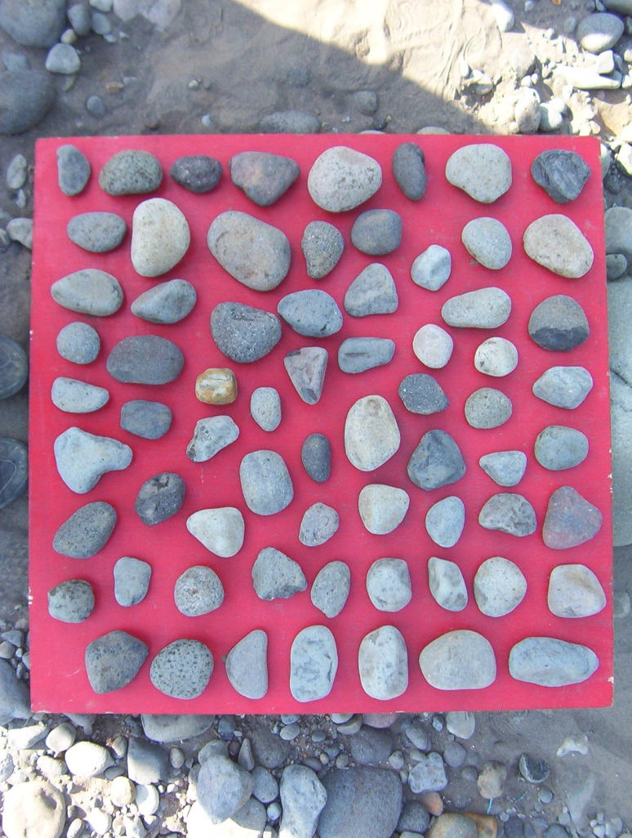

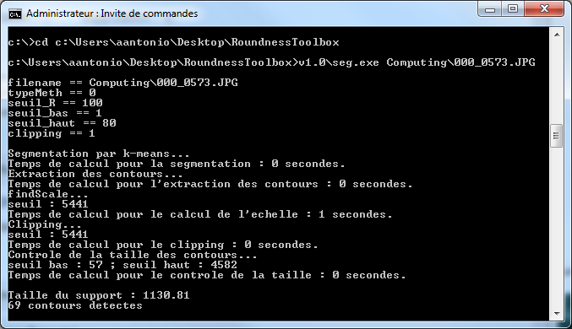

At the beginning, program reminds your image input filename and values given for 5 parameters.

* typeMeth = method type (0,1 or 2 – 0 is the best one, default = 0)
* seuil_R = red threshold initialization (value between 0 and 255 – recommended values between 100 and 150, default = 100)
* seuil_bas = delete boundary on lower threshold (value between 0 and 100 - recommended values 2 or 3, default = 1)
* seuil_haut = delete boundary on upper threshold (value between 0 and 100 - recommended values 75, default = 80)
* clipping = delete wrong detection out the board (0 = no, 1 = yes, default= no)

The last 2 lines :

Taille du support = board size in pixels (here 1130.81 pixels)

X contours detectes = number of detected pebbles boundaries (here 69 boundaries)

If these values are not credible, it means that the board detection failed. Please launch again seg.exe with other parameters value. To change parameters value, just add them at the end of the command line.

For example:

v1.0\seg.exe Computing\000_0573.jpg 0 150 3 75 0

**Results:**

3 files are created in the same folder of the image given in input (000_0573.jpg).

* 000_0573-B.jpg : black and white board
* 000_0573-R.jpg : result image. This file needs to be checked to confirm the segmentation program efficiency
* 000_0573Input.txt: data file which will be computed by the description program, see next step

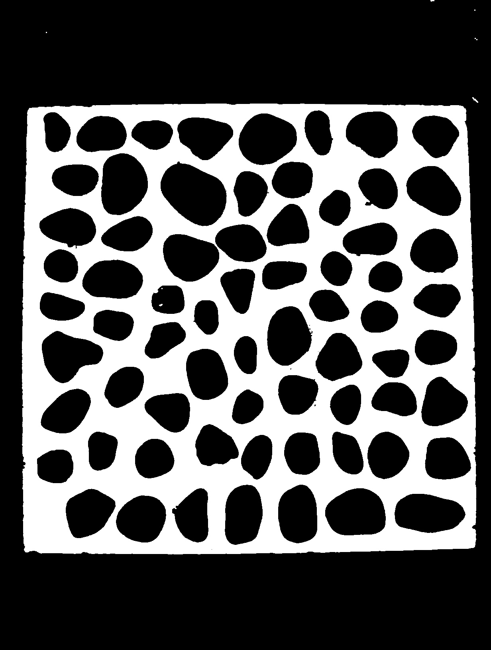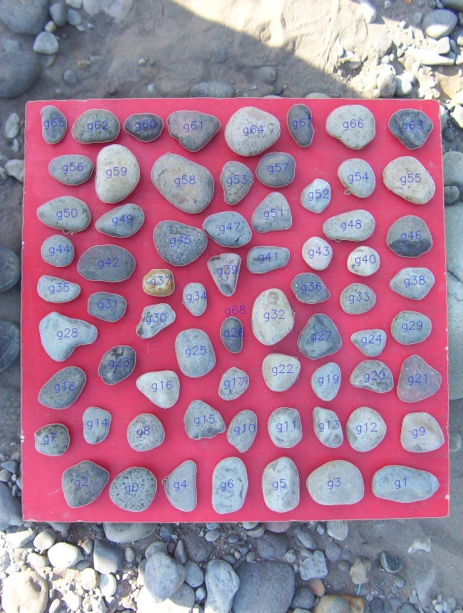

# Description

desc.exe calculates each parameter of each pebble.

Open a DOS commands window and move to the 2D roundness toolbox path for example C:\Users\aantonio\Desktop\RoundnessToolbox.

cd C:\Users\aantonio\Desktop\RoundnessToolbox

Then launch desc.exe automatic computing with the path of your data input file (see previous step to obtain this data file).

v1.0\desc.exe Computing\000_0573Input.txt

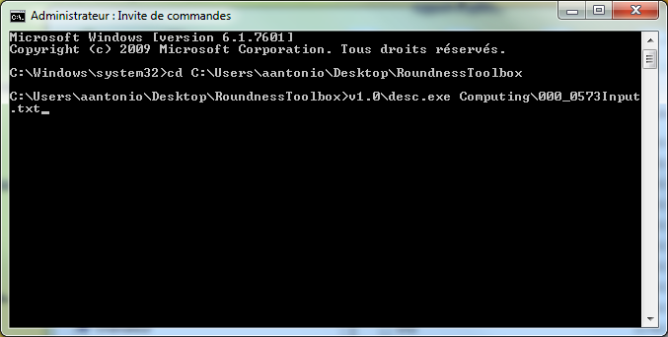

Each calculation is made on each pebble. Computation could take a moment.

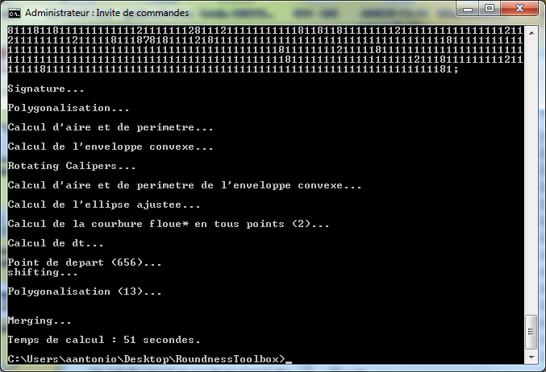

**Results:**

1 file is created in the same folder of the data file given in input (000_0573Input.txt).

* 000_0573Output.txt : data file. You can open it in Excel for an easier reading (see below)

8 text files are created in C:\Users\aantonio\Desktop\RoundnessToolbox (BDSS.txt, CH.txt, courbure.txt, DSS.txt, NBC.txt, regular.txt, reverse.txt, RotatingCalipers.txt). They were needed for intermediate calculation. You can destroy them.

How to read results file :

A text file named xxxOutput.txt is created for each computing. If you open it with a text editor software, you’ll see that it’s not easily legible (data are separated by a comma, one line by pebble).

It’s better to open it with Excel or Open Office Calc software. Excel will start the Import Text Wizard, choose “Delimited” and go to next step. Choose “comma” as separator character, next step choose “standard”. Click “Finish” to complete the import operation, then a 28 columns table is created.

Columns have no title. Please add a new row, and complete as proposed in example file : RoundnessToolbox/ResultDatabase/000_0573Output.xls

Example file RoundnessToolbox/ResultDatabase/ColumNames.xls proposed correlation between column names given in the original documentation and nouns used in the publication of 2009.

Be careful because the coordinates of the first point (XXXX,YYYY) in the output.txt file becomes a negative value in the .xls file. It means nothing and must not be used ! (colored in red in the example file 000_0573Output.xls)

# Process automation

You can always use seg.exe and desc.exe board by board but you will be perhaps interested in automation process to compute several images simultaneously. Automation is made thanks to “.bat” files in “v1.0” folder.

Automation process needs to have image dataset in the same folder of programs (.exe and .bat), for example C:\Users\aantonio\Desktop\RoundnessToolbox\v1.0

***Segmentation process automation:***

2 .bat files are available

seg0.bat launches segmentation process on each .jpg file with these parameters :

* typeMeth = 0
* seuil_R = 100
* seuil_bas = 3
* seuil_haut = 75
* clipping = 0

seg1.bat launches segmentation process on each .jpg file with these parameters :

* typeMeth = 0
* seuil_R = 100
* seuil_bas = 3
* seuil_haut = 75
* clipping = 1

Copy your images files in the programs folder, for example C:\Users\aantonio\Desktop\RoundnessToolbox\v1.0. In this example, 2 image files are used (000_0635.jpg and 000_0785.jpg)

Open a DOS commands window and move to the 2D roundness toolbox programs path for example C:\Users\aantonio\Desktop\RoundnessToolbox\v1.0.

cd C:\Users\aantonio\Desktop\RoundnessToolbox\v1.0

Then launch seg0.bat or seg1.bat. Each .jpg file will be computed, here 000_0635.jpg and 000_0785.jpg

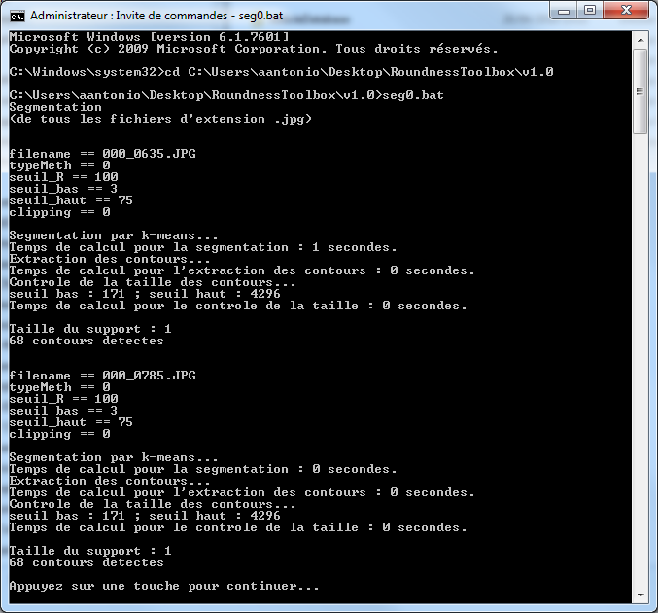

**Results:**

3 files are created for each input image.

We have 2 input image files (000_0635.jpg and 000_0785.jpg) so results are: 000_0635-B.jpg, 000_0635-R.jpg, 000_0635Iput.txt, 000_0785-B.jpg, 000_0785-R.jpg and 000_0785Input.txt

***Description process automation:***

desc.bat launches description process on each *Input.txt file then concatenate results in one file called “desc.txt”.

Copy your input files in the programs folder, for example C:\Users\aantonio\Desktop\RoundnessToolbox\v1.0. In this example, 2 input files are used (000_0635Input.txt and 000_0785Input.txt)

Open a DOS commands window and move to the 2D roundness toolbox programs path for example C:\Users\aantonio\Desktop\RoundnessToolbox\v1.0.

cd C:\Users\aantonio\Desktop\RoundnessToolbox\v1.0

Then launch desc.bat

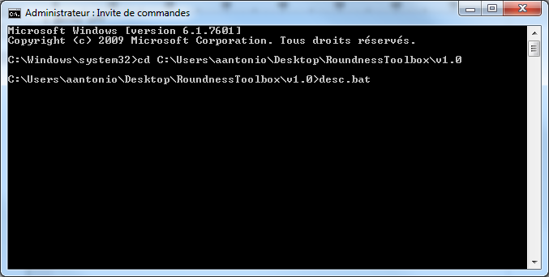

Each calculation is made on each pebble of each input file. Computation could take a moment.

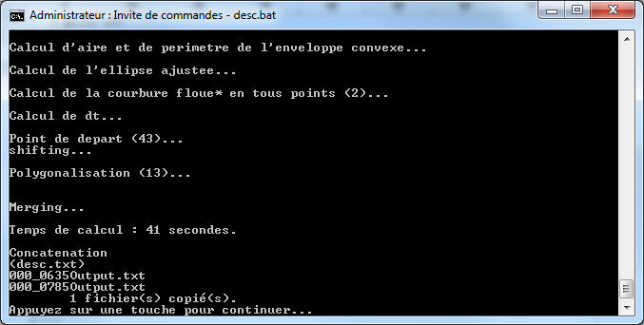

**Results:**

For each input file (XInput.txt) an output file is created (XOutput.txt).

An additional file is created (desc.txt) which concatenates results of all output files. You can open it in Excel for an easier reading.

8 other text files are created (BDSS.txt, CH.txt, courbure.txt, DSS.txt, NBC.txt, regular.txt, reverse.txt, RotatingCalipers.txt). They were needed for intermediate calculation. You can destroy them.